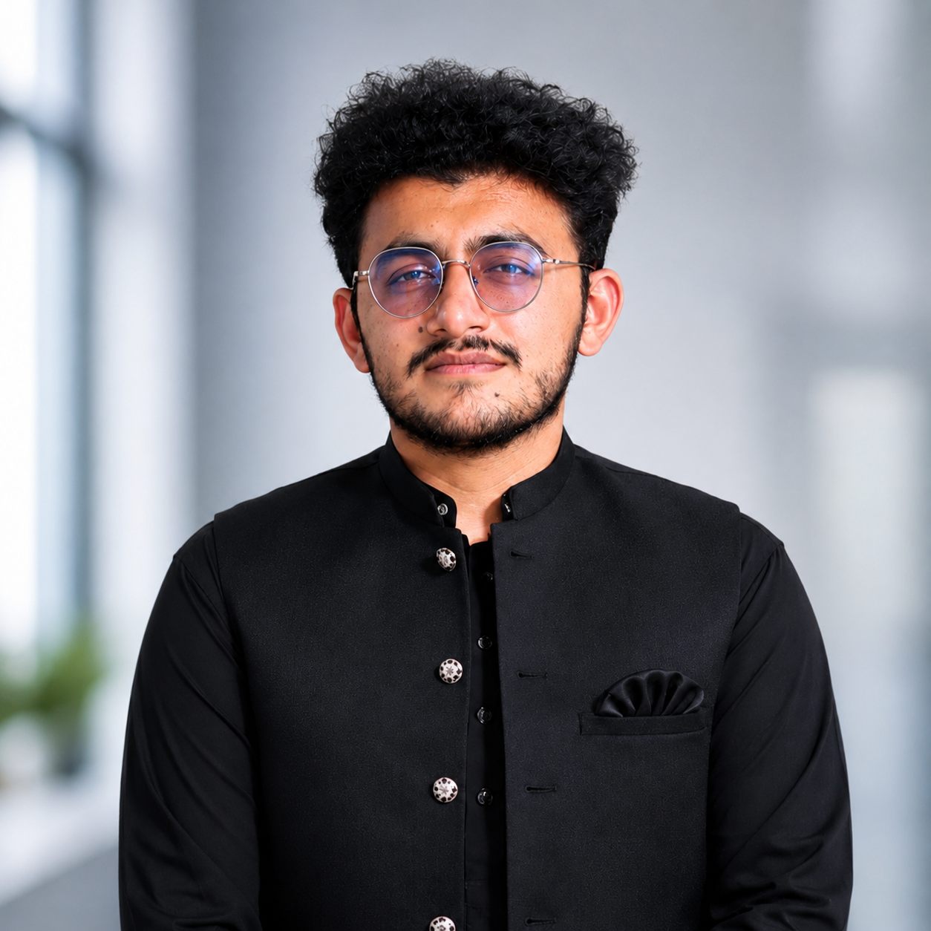
Muhammad Usman
📍 Nankana Sahib, Punjab, Pakistan
📞 03000437358
✉ usmanboota.dev@gmail.com
LinkedIn: linkedin.com/in/musman100official
Github: https://github.com/useratnns
Portfolio: usman.corecslab.me

PROFESSIONAL SUMMARY
Motivated BS Computer Science student with expertise in Artificial Intelligence, Full-Stack Development, Cybersecurity, research, leadership, and community building. Currently serving as Google Student Ambassador 2026, GeeksforGeeks Campus Mantri, President of SCALE, and Lead Student Representative, committed to building innovative technology solutions and empowering student communities.

EDUCATION
Baba Guru Nanak University
Bachelor of Science (BS) in Computer Science (2023–2027)
Allama Iqbal Open University
Certificate in Librarianship (CLS)

LEADERSHIP & EXPERIENCE
President — SCALE: Lead academic workshops, mentorship sessions, and student engagement initiatives. Collaborate with university administration to promote innovation, leadership, and professional development.
Google Student Ambassador: Organize AI awareness sessions and promote Google Gemini technologies across campus. Build an active developer community through workshops and technical events.
GeeksforGeeks Campus Mantri: Represent GeeksforGeeks by conducting coding events and outreach activities. Mentor students and strengthen the campus developer community.
Lead Student Representative (LSR): Represent students in academic quality assurance meetings. Coordinate communication between students, faculty, and university administration.
Finance Secretary — DMC: Manage financial records, budgeting, and event documentation. Ensure transparency in expenditure reporting and resource allocation.
Research Presenter — ICAST 2025: Presented AI research at an international conference. Became the first BGNU student to represent the university as a research presenter.
Dispenser Technician: Provide prescription preparation and patient support under supervision. Maintain healthcare records while following safety protocols.
Hunza Sugar Mills Internship: Worked on industrial automation and AI-assisted monitoring. Assisted with process optimization and operational analysis.
Punjab Police Internship: Learned administration, documentation, and reporting procedures. Strengthened discipline, teamwork, and communication skills.
HR & Administrative Support: Supported documentation and departmental coordination. Assisted in planning academic and technical events.
Media Coverage & Event Coordination: Managed photography and media coverage for university events. Produced visual content and supported event management.

PROJECTS:
- StudyHub LMS: Learning Management System using Next.js, Prisma and PostgreSQL.
- EvaLock : Offline first Presentation Evaluation System.
- Campus Connect: Flutter application with AI chatbot and campus services.
- Honey Bee Venom Extractor Machine: Interdisciplinary innovation project presented at BGNU.
- Personal Portfolio: Designed and deployed a responsive portfolio showcasing projects, certifications, achievements, blogs, and technical expertise using Next.js, React, and Tailwind CSS.
- Fake News Detection System: Developed a Machine Learning application using Python, NLP, and Scikit-learn to classify news articles and detect misinformation with predictive analytics.
- Heart Disease Prediction System: Implemented a predictive healthcare model using Python, Machine Learning, and Data Analysis to estimate heart disease risk based on patient health indicators.
- Stock Price Prediction: Built a machine learning model using Python, Pandas, NumPy, and TensorFlow to analyze historical stock market data and forecast future price trends.
- MERN Chat Application: Developed a real-time chat application using the MERN Stack, Socket.io, JWT Authentication, and MongoDB with secure messaging and user authentication.
- MERN E-Commerce Platform: Built a full-stack e-commerce application using React.js, Node.js, Express.js, MongoDB, and Stripe featuring authentication, product management, shopping cart, and online payments.

TECHNICAL SKILLS
Python, C++, JavaScript, SQL, HTML, CSS, Tailwind CSS, React.js, Next.js, Node.js, Flutter, PostgreSQL, Firebase, Prisma ORM, Prompt Engineering, Google Gemini, Claude AI, MCP, Git, GitHub, Linux, VS Code, Figma

CERTIFICATIONS
- Google UX Design Professional Certificate
- Google Cybersecurity Professional Certificate
- Google Project Management Professional Certificate
- Google Digital Marketing & E-commerce Professional Certificate
- Google Prompting Essentials
- Gemini Certified Student – Google for Education
- Model Context Protocol (Advanced Topics)
- Introduction to Model Context Protocol
- Claude with the Anthropic API
- AI Fluency for Students
- Cisco Network Technician Career Path
- Cisco Introduction to Cybersecurity
- Networking Basics
- Introduction to IoT
- IBM Python 101 for Data Science
- IBM Prompt Engineering for Everyone
- IBM HTML
- HP LIFE – AI for Beginners
- Certificate in Librarianship
- Police Internship Certificate
- Presented Research Paper – ICAST 2025
- Security Management – ICAST 2025
- Media Coverage – Sports Gala 2025
- INTF 1.0 Certificate of Appreciation

HONORS & ACHIEVEMENTS
- Google Student Ambassador for Gemini 2026
- GeeksforGeeks Campus Mantri
- First BGNU Student Research Presenter – ICAST 2025
- 1st Position – DLD Project Display (ICAST 2024)
- Gold Medal – Chess Champion (2024 & 2025)
- Silver Medal – Media Coverage (Sports Gala 2025)

LANGUAGES
English • Urdu • Punjabi

